Case Study: Real-Time Ranking System Using Quick Sort

NAME:A.Siva suraj sai
Register no:192425276
Course code:CSA0609
Title
Real-Time Ranking System Using Quick Sort

Description of the Real-World Problem
In many real-world applications such as online gaming platforms, coding competitions, sports tournaments, stock market dashboards, and live examination portals, participant scores change continuously. Whenever a score is updated, the leaderboard must instantly display the correct ranking.
For example, in an online coding contest, thousands of participants submit solutions every minute. The system must sort the updated scores quickly so that users always see the latest rankings. Since these updates occur frequently, an efficient sorting algorithm is essential to maintain fast response times.
Quick Sort is a suitable algorithm because it provides excellent average-case performance and sorts data efficiently. However, improper pivot selection can lead to poor performance, making pivot optimization an important aspect of the algorithm.

Problem Statement
Design an efficient sorting mechanism for a real-time ranking system where participant scores are updated dynamically. The algorithm should:
- Sort scores quickly after every update.
- Display the latest leaderboard with minimal delay.
- Handle large datasets efficiently.
- Reduce the possibility of worst-case execution time.
- Use optimized pivot selection to improve performance.

Algorithm Used
Quick Sort (Divide and Conquer Algorithm)
Quick Sort works by repeatedly dividing the array into smaller sub-arrays based on a selected pivot element.
Steps
- Select a pivot element.
- Partition the array into:
  - Left side → Elements smaller than pivot.
  - Right side → Elements greater than pivot.
- Recursively apply Quick Sort on both partitions.
- Combine the sorted partitions.
Optimized Version
Instead of always choosing the first or last element as the pivot, a Randomized Pivot Selection is used.
Random Pivot:
- Randomly select any element.
- Swap it with the last element.
- Continue normal Quick Sort.
This greatly reduces the probability of worst-case performance.

Justification for Choosing the Algorithm (Why Quick Sort?)
Quick Sort is chosen because:
- It has an average time complexity of O(n log n).
- It performs faster than Merge Sort in practice due to smaller constant factors.
- It requires less additional memory because it is an in-place sorting algorithm.
- It is ideal for dynamically changing datasets.
- Randomized pivot selection minimizes the chances of worst-case performance.
- Suitable for leaderboards that require frequent updates.

Complexity Analysis
Case | Time Complexity | Space Complexity
Best Case | O(n log n) | O(log n)
Average Case | O(n log n) | O(log n)
Worst Case | O(n²) | O(n)
Explanation
Best Case
- Pivot divides the array equally.
- Balanced recursion tree.
- Fast execution.
Average Case
- Random data creates nearly balanced partitions.
- Efficient performance.
Worst Case
- Occurs when pivot is always the smallest or largest element.
- Example:
  - Already sorted array
  - Reverse sorted array
- Leads to highly unbalanced partitions.
Randomized Pivot Selection significantly reduces this possibility.

Manual Execution (Step-by-Step Process)
Initial Scores
[85, 42, 96, 33, 77, 68, 90]
Step 1: Choose Random Pivot
Suppose the pivot selected is 68.
Pivot = 68

Step 2: Partition
Left Side (<68)
42, 33
Pivot
68
Right Side (>68)
85, 96, 77, 90

Step 3: Sort Left Side
42,33
Choose Pivot = 33
Left
[]
Pivot
33
Right
42
Sorted Left
33,42

Step 4: Sort Right Side
85,96,77,90
Choose Pivot = 90
Partition
Left
85,77
Pivot
90
Right
96
Sort Left
Choose Pivot = 77
77,85
Sorted Right
77,85,90,96

Final Sorted Scores
Ascending
33,42,68,77,85,90,96
Leaderboard (Descending)
96
90
85
77
68
42
33

Applications
Quick Sort is widely used in:
- Online gaming leaderboards
- Coding competition rankings
- Live sports scoreboards
- University examination result systems
- E-commerce product ranking
- Stock market ranking systems
- Cryptocurrency price ranking
- Real-time analytics dashboards

Advantages
- Very fast average-case performance.
- Efficient for large datasets.
- Uses Divide and Conquer strategy.
- Requires less memory (in-place sorting).
- Cache-friendly implementation.
- Suitable for real-time applications.
- Random pivot improves reliability.
- Faster than many sorting algorithms in practical scenarios.

Limitations
- Worst-case complexity is O(n²).
- Performance depends on pivot selection.
- Not a stable sorting algorithm.
- Recursive implementation may cause stack overflow for extremely large inputs.
- Poor pivot choice results in unbalanced partitions.

Comparison with Other Algorithms
Algorithm | Best Case | Average Case | Worst Case | Stable | Space
Quick Sort | O(n log n) | O(n log n) | O(n²) | No | O(log n)
Merge Sort | O(n log n) | O(n log n) | O(n log n) | Yes | O(n)
Heap Sort | O(n log n) | O(n log n) | O(n log n) | No | O(1)
Bubble Sort | O(n) | O(n²) | O(n²) | Yes | O(1)
Insertion Sort | O(n) | O(n²) | O(n²) | Yes | O(1)
Why Quick Sort is Better
- Faster in practice than Merge Sort due to lower constant overhead.
- Requires less additional memory.
- Ideal for large datasets with frequent updates.
- Randomized pivot selection makes worst-case scenarios rare.
- Well-suited for dynamic leaderboard applications.

Screenshot of the Program
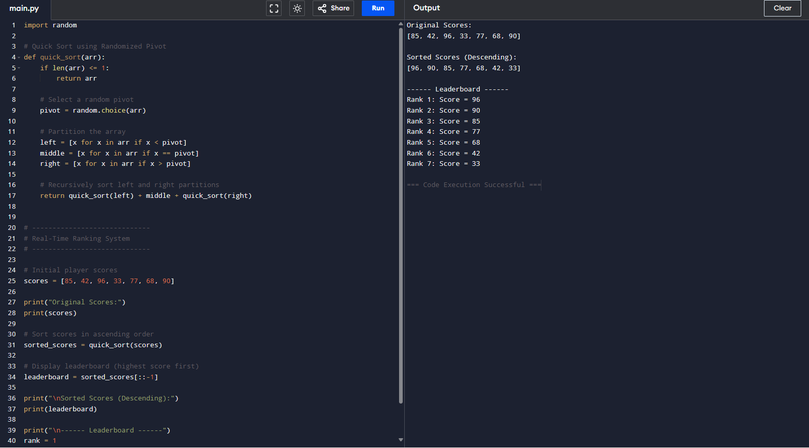
Output Screenshot
Example output:
Original Scores:
85 42 96 33 77 68 90

Sorted Scores:
96 90 85 77 68 42 33

----- Leaderboard -----

Rank 1 : 96
Rank 2 : 90
Rank 3 : 85
Rank 4 : 77
Rank 5 : 68
Rank 6 : 42
Rank 7 : 33

Conclusion
A real-time ranking system requires a sorting algorithm that is both fast and efficient. Quick Sort is an excellent choice because it uses the Divide and Conquer strategy, achieving an average time complexity of O(n log n) while sorting large datasets quickly with minimal memory usage. However, its performance depends heavily on pivot selection, and a poor pivot can lead to O(n²) execution time. Using Randomized Pivot Selection significantly reduces the likelihood of this worst-case scenario by creating more balanced partitions. As a result, optimized Quick Sort provides fast, reliable, and scalable performance, making it highly suitable for applications such as online gaming leaderboards, coding competitions, sports rankings, and other real-time score management systems.

